**IPL CRICKET DATA ANALYSIS PROJECT**

### **Project Overview:**

Analysing IPL Match’s Data For a Sports Company To Gain Insights And Improve Decision-Making.

### 

### **Project Objective:**

Generate A comprehensive Dynamic Dashboard’s To Analyze And Visualize Match’s Data For A Sports Company.

### **Project Requirements:**

* Problem Statement
* Data Source
* Software’s Required

**Problem Statement:**

**KIP’S Requirement:**

**Primary Insights:**

1. Top 10 batsmen based on past 3 years total runs scored.
2. Top 10 batsmen based on past 3 years batting average. (min 60 balls faced in each season)
3. Top 10 batsmen based on past 3 years strike rate (min 60 balls faced in each season)
4. Top 10 bowlers based on past 3 years total wickets taken.
5. Top 10 bowlers based on past 3 years bowling average. (min 60 balls bowled in each season)
6. Top 10 bowlers based on past 3 years economy rate. (min 60 balls bowled in each season)
7. Top 5 batsmen based on past 3 years boundary % (fours and sixes).
8. Top 5 bowlers based on past 3 years dot ball %.
9. Top 4 teams based on past 3 years winning %.
10. 10.Top 2 teams with the highest number of wins achieved by chasing targets over the past 3 years.

**Secondary Insights:**

Predict the following for the season 2024 using available data and by doing additional research

1. Orange and purple cap player
2. Top 4 qualifying teams
3. Winner and runner-up Your Picks
4. Pick your team selecting the Best 11 players based on their positions, 3 years performance data and additional Research
5. Top 3 All-Rounders

**Data Source:**

The Data Collected From The Stakeholders Of Pizza Business

Data Collection Tool : MS excel

**Software’s Used:**

Database : MY SQL

BI Tool : Microsoft Power BI

### **Project Process:**

**Step By Step Process:**

1. Collecting the Data set
2. Importing Data set Into MYSQL Data base
3. Writing The SQL Queries To Evaluate The Values
4. Creating Report For MYSQL Server
5. Connect MYSQL Server To Power BI
6. Data Cleaning
7. Data Processing
8. Data Visualization
9. Final Dash Board

**1.Collecting Data**

The Data set collected From The pizza Business Stakeholder’s In The Form Of Excel Sheets.

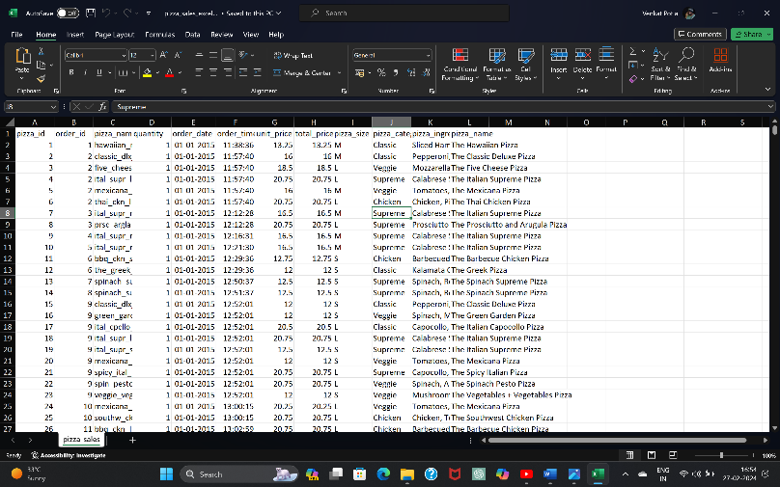

**2.Importing Data set Into MYSQL Database**

* To Import Dataset into The MYSQL Database, first We Need To create A New Database

Syntax: Create Database Database_name;

Create Database Pizza_DB;

* To Import the Dataset Into The Database, Right click on Database Name, Go To Table Data Import Wizard ,and Then Choose file That We want To Import Into Database.
* After a successful Import ,The Data Will Be Displayed In the Form Of A Table. We Can Retrieve The Table Data By Writing Queries.

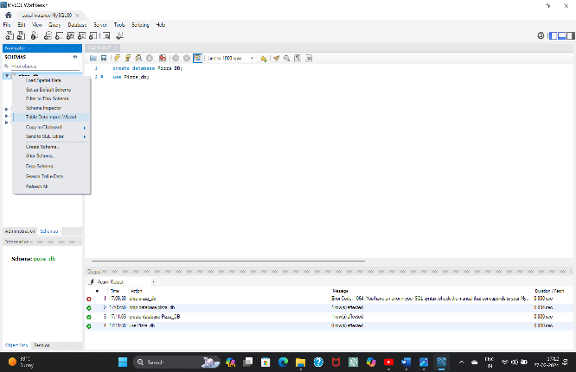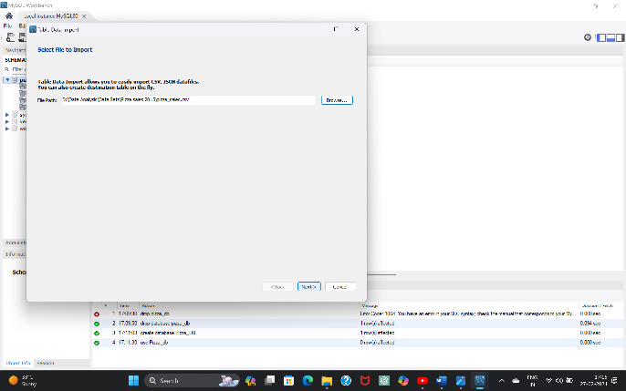

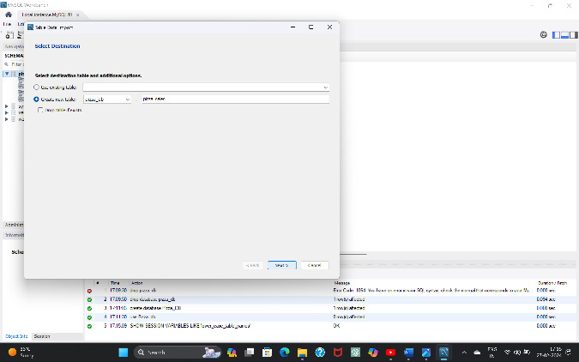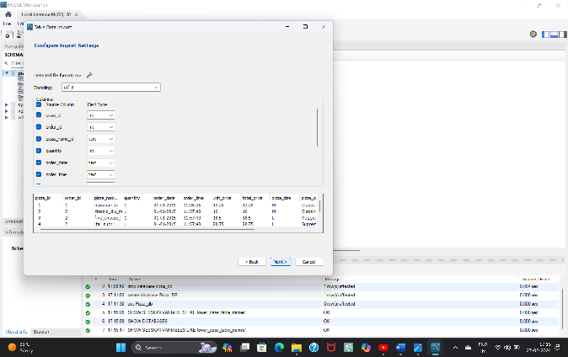

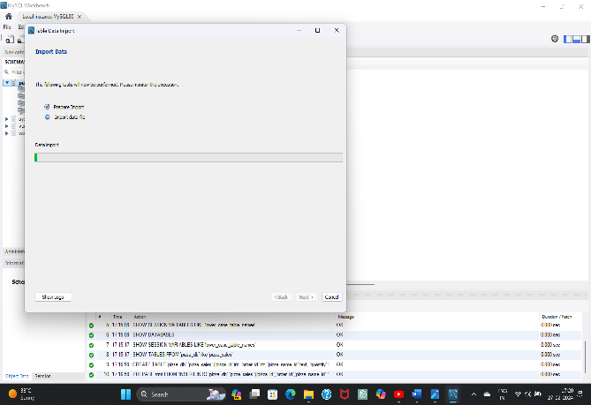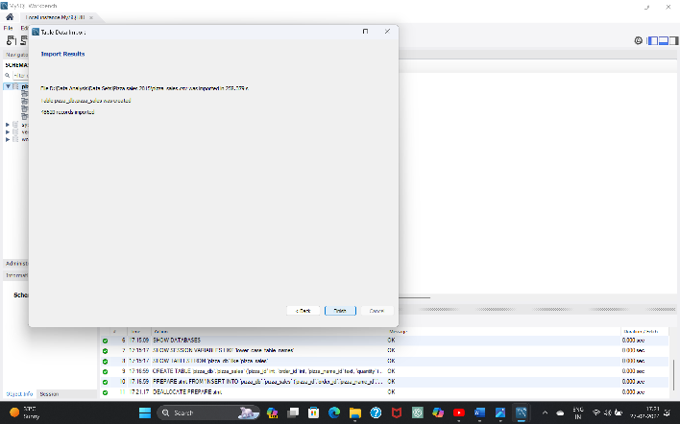

* After Importing, Retrieve The table data By Writing DQL Commands.

Syntax: Select * From Table_name;

Select * From Pizza_sales;

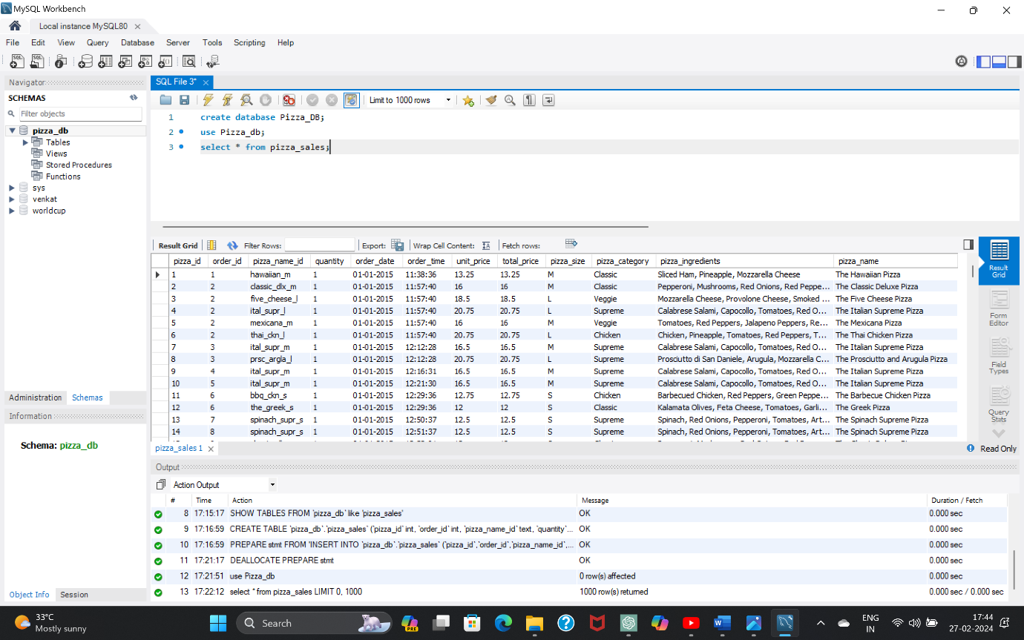

**3.writing The Queries To Evaluate The Values**

**Here, I’m Writing SQL Queries Based On the Requirements To Evaluate The Values For Dashboards.**

1. **Total Revenue**

**select sum(total_price) as Total_Revenue From Pizza_sales;**

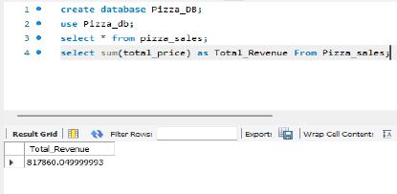

1. **Average Order Value**

**select sum(total_price)/count(distinct order_id) as Avg_Order_vaule From pizza_sales;**

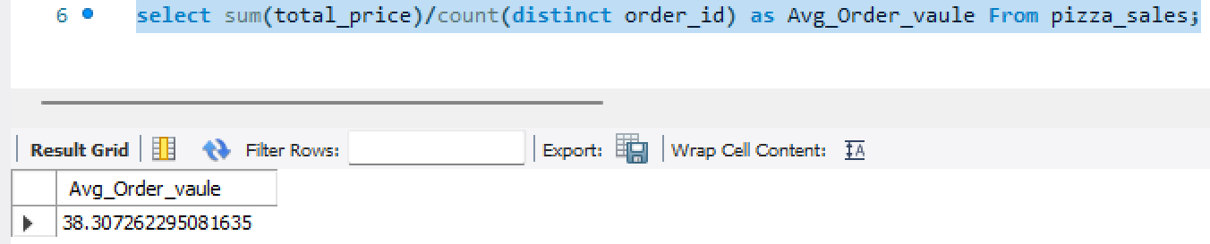

1. **Total Pizza Sold**

**select sum(quantity) as Total_pizza_sold from pizza_sales;**

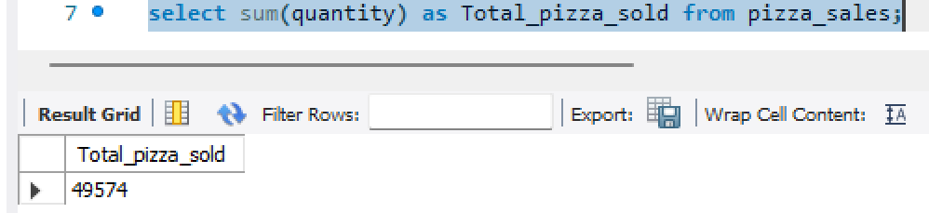

1. **Total Orders**

**select count(distinct order_id) as Total_Orders from pizza_sales;**

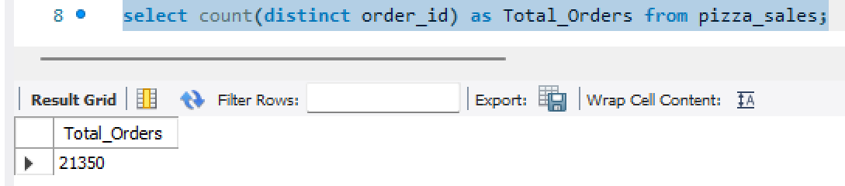

1. **Average Pizza Per Order**

**select cast(sum(quantity) as decimal(10,2)) / cast(count(distinct order_id) as decimal(10,2)) as Avg_pizza_per_order from pizza_sales;**

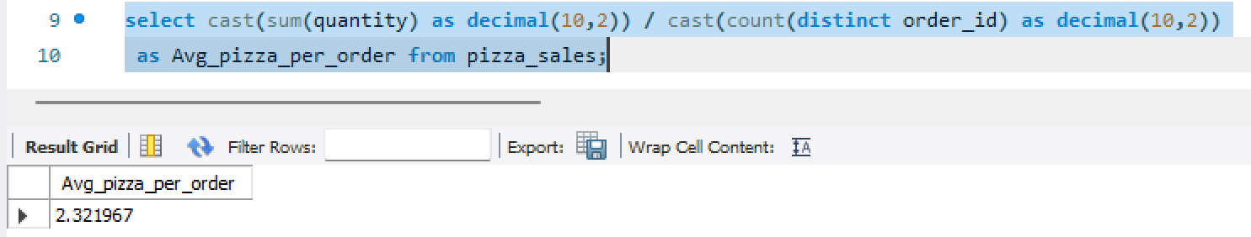

1. **Daily Trend For Total Orders**

**select dayname(order_date) as Order_day,count(distinct order_id) as Total_orders from pizza_sales group by dayname(order_date);**

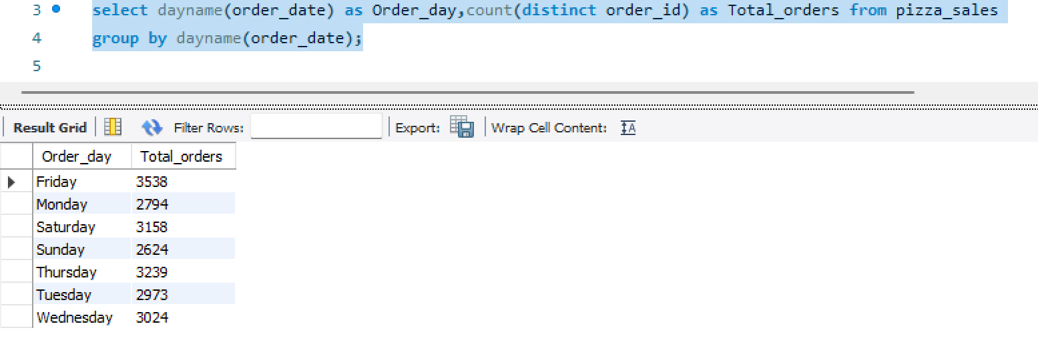

1. **Monthly Trend For Total Orders**

**select monthname(order_date) as Month_Name,count(distinct order_id) as Total_orders from pizza_sales group by monthname(order_date);**

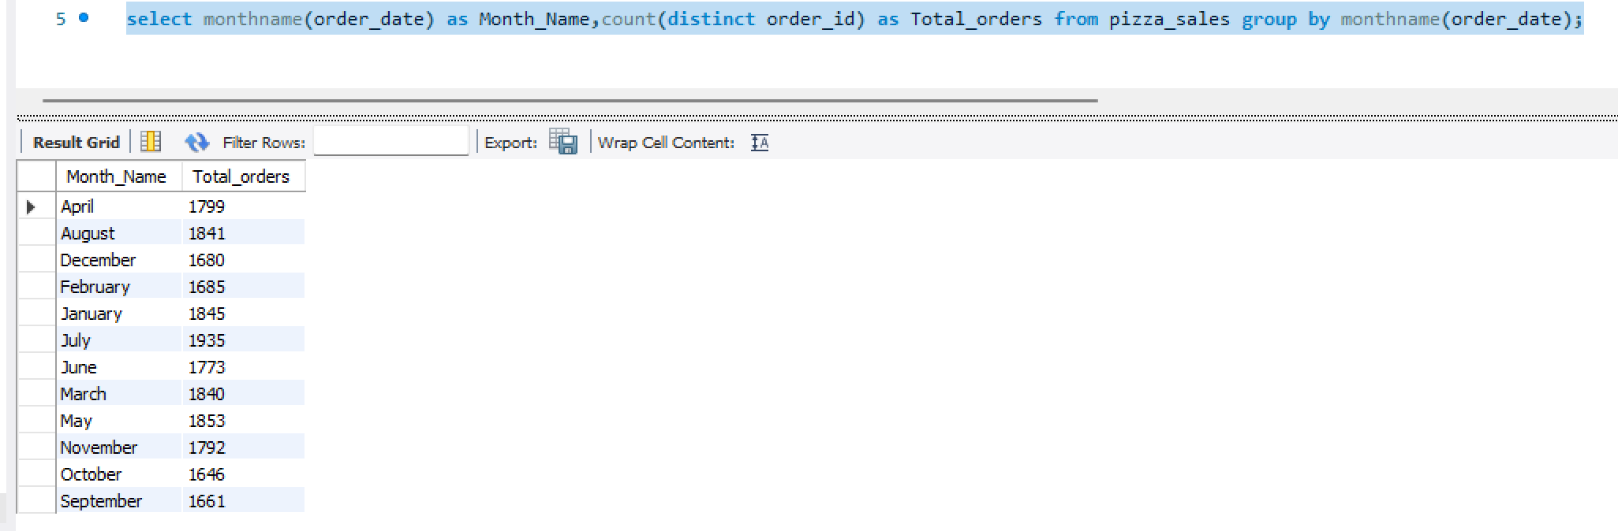

1. **Percentage of sales By Pizza category**

**select pizza_category,sum(total_price) *100 / (select sum(total_price) from pizza_sales) as Totalcategory_percentage from pizza_sales group by pizza_category;**

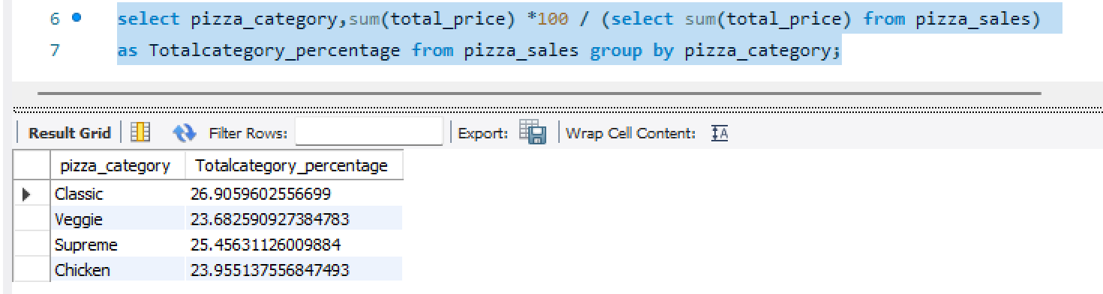

**select pizza_category,sum(total_price) as Total_Revenue,sum(total_price) *100 / (select sum(total_price) from pizza_sales where month(order_date) in (1,2,3,4)) as Totalcategory_percentage from pizza_sales where month(order_date) in (1,2,3,4) group by pizza_category;**

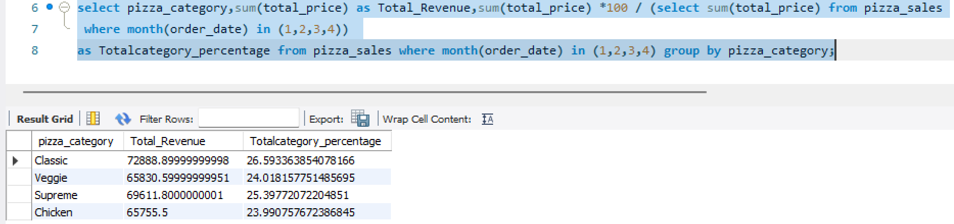

1. **Percentage of sales By Pizza Size**

**select pizza_size,sum(total_price) as Total_Revenue,sum(total_price) *100 / (select sum(total_price) from pizza_sales) as Totalcategory_percentage from pizza_sales group by pizza_size;**

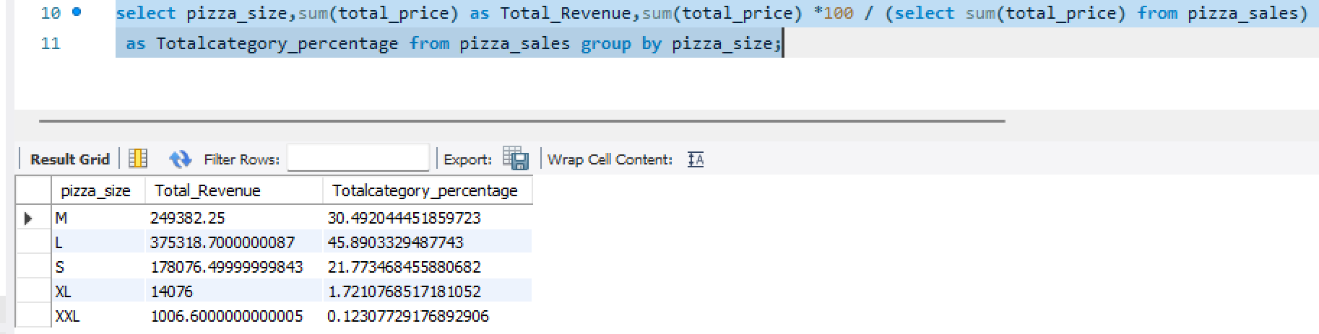

1. **Total Pizza Sold By Pizza category**

**select pizza_category,count(distinct order_id) as Totalpizza_sold from pizza_sales group by pizza_category;**

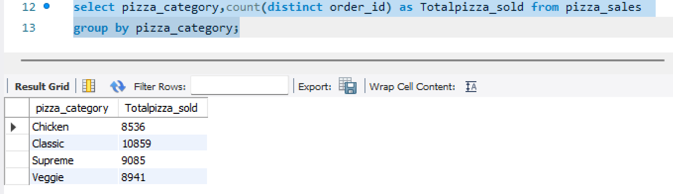

1. **Top 5 Best Seller’s By Revenue, Total Quantity and Total Order’s**

**select pizza_name,sum(total_price) as Total_Revenue from pizza_sales group by Pizza_name order by Total_Revenue desc limit 5;**

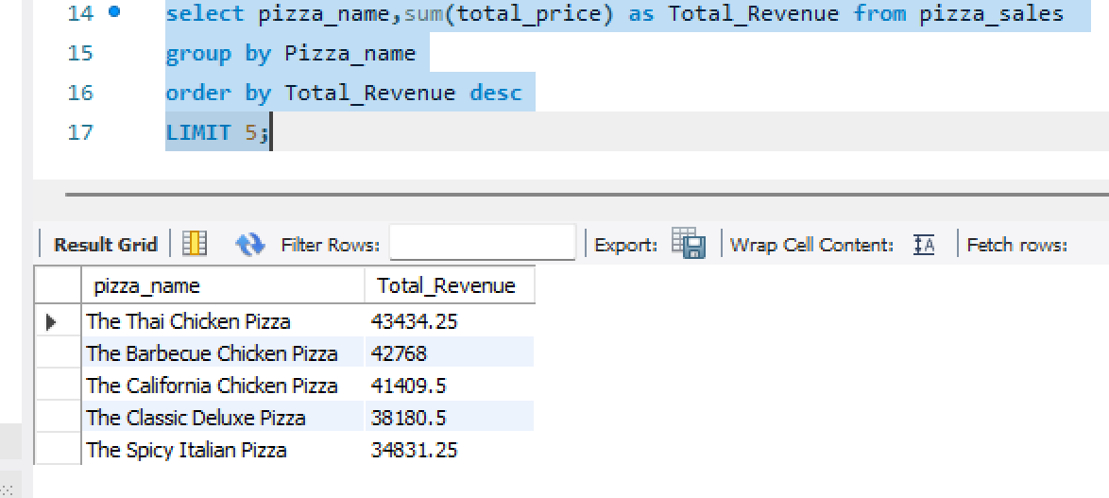

**select pizza_name,sum(quantity) as Total_Quantity from pizza_sales group by Pizza_name order by Total_Quantity desc limit 5;**

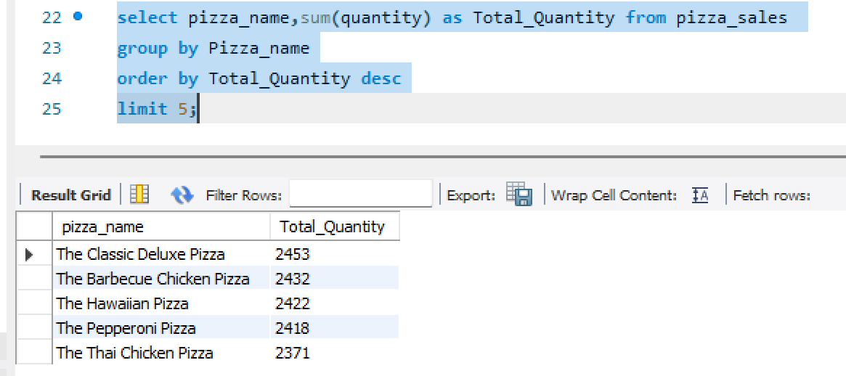

**select pizza_name,count(distinct order_id) as Total_orders from pizza_sales group by Pizza_name order by Total_orders desc limit 5;**

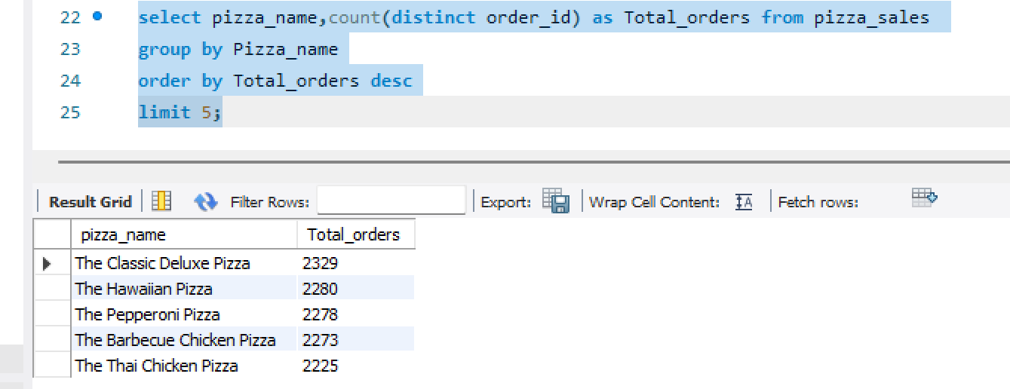

1. **Bottom 5 Worst Seller’s By Revenue, Total Quantity and Total Order’s**

**select pizza_name,sum(total_price) as Total_Revenue from pizza_sales group by Pizza_name order by Total_Revenue asc limit 5;**

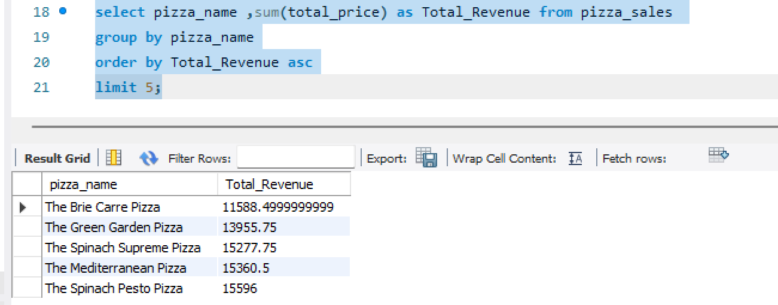

**select pizza_name,sum(quantity) as Total_Quantity from pizza_sales group by Pizza_name order by Total_Quantity asc limit 5;** 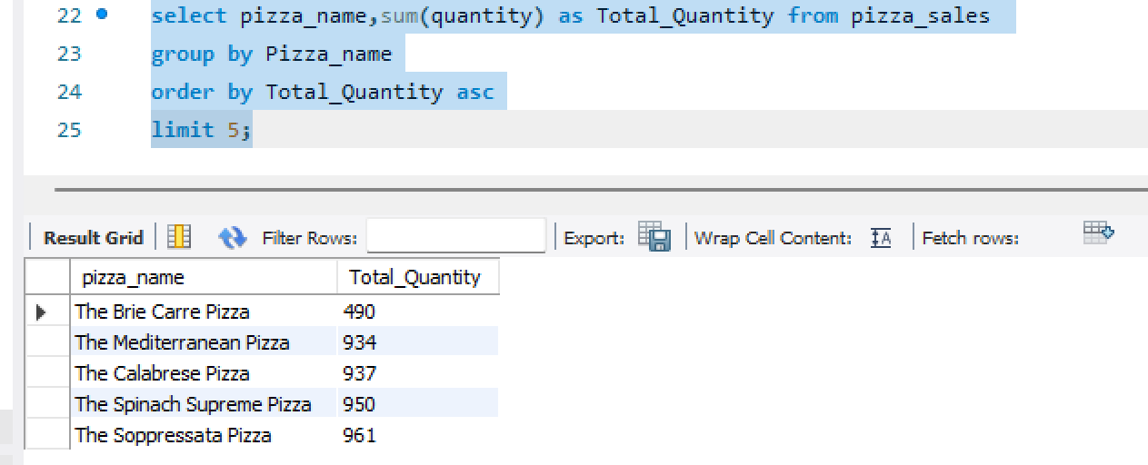

**select pizza_name,count(distinct order_id) as Total_orders from pizza_sales group by Pizza_name order by Total_orders asc limit 5;**

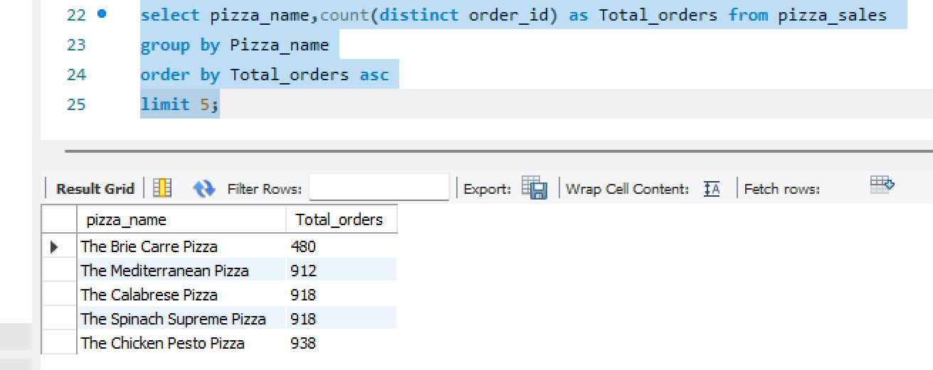

**4.Creating Report For MYSQL Server**

Now, Save All The Queries That We Wrote To Evaluate the Values With The Dashboards. Create a Report For MYSQL Queries

**5.Connect MYSQL Server With Power BI**

* For That, Open Power BI, Go to Get Data and Select MYSQL Database Then, Make a Connection With MYSQL Database

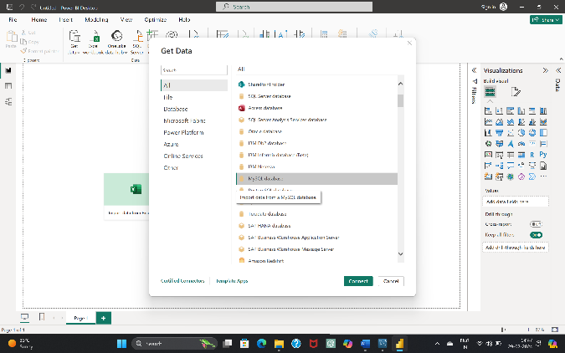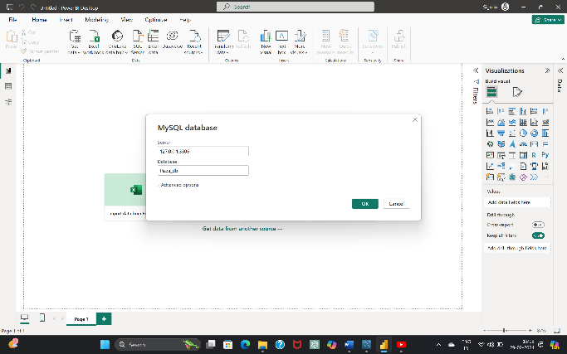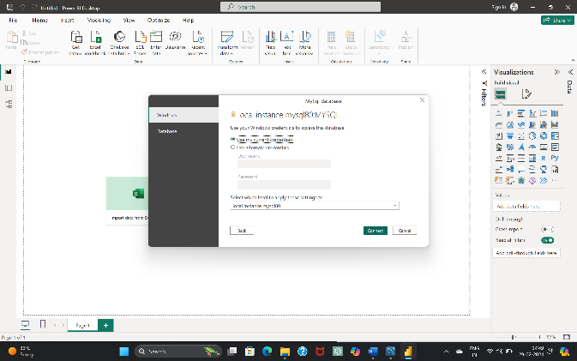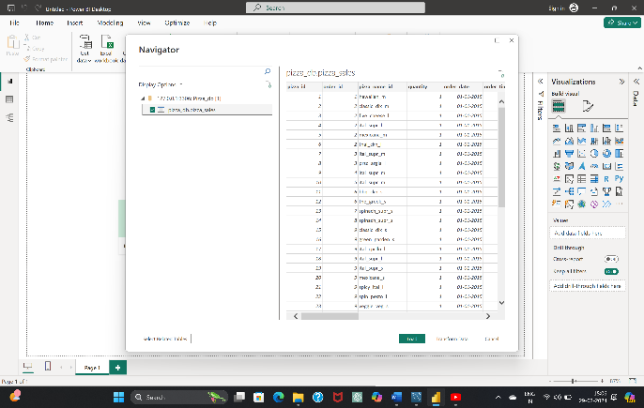

* After Completion of Connection we can Load Or Transform Data Based On Requirement

**6.Data Cleaning &Processing**

* After Loading Data Into PowerBI By Using The Power Query Editor, We Perform DAX(Data Analysis Express) For Data cleaning and Processing
* These Are Some Of DAX Formulas written for Data Visualization

1. Total Orders = DISTINCTCOUNT('pizza_db pizza_sales'[order_id])
2. Total Pizza Sold = sum('pizza_db pizza_sales'[quantity])
3. Total Revenue = sum('pizza_db pizza_sales'[total_price])
4. Avg Pizzas Per Order = [Total Pizza Sold]/[Total Orders]
5. Avg Order Value = [Total Revenue]/[Total Orders]
6. Order Day = upper(LEFT('pizza_db pizza_sales'[Day Name],3))
7. Order Month = upper(LEFT('pizza_db pizza_sales'[Month Name],3))

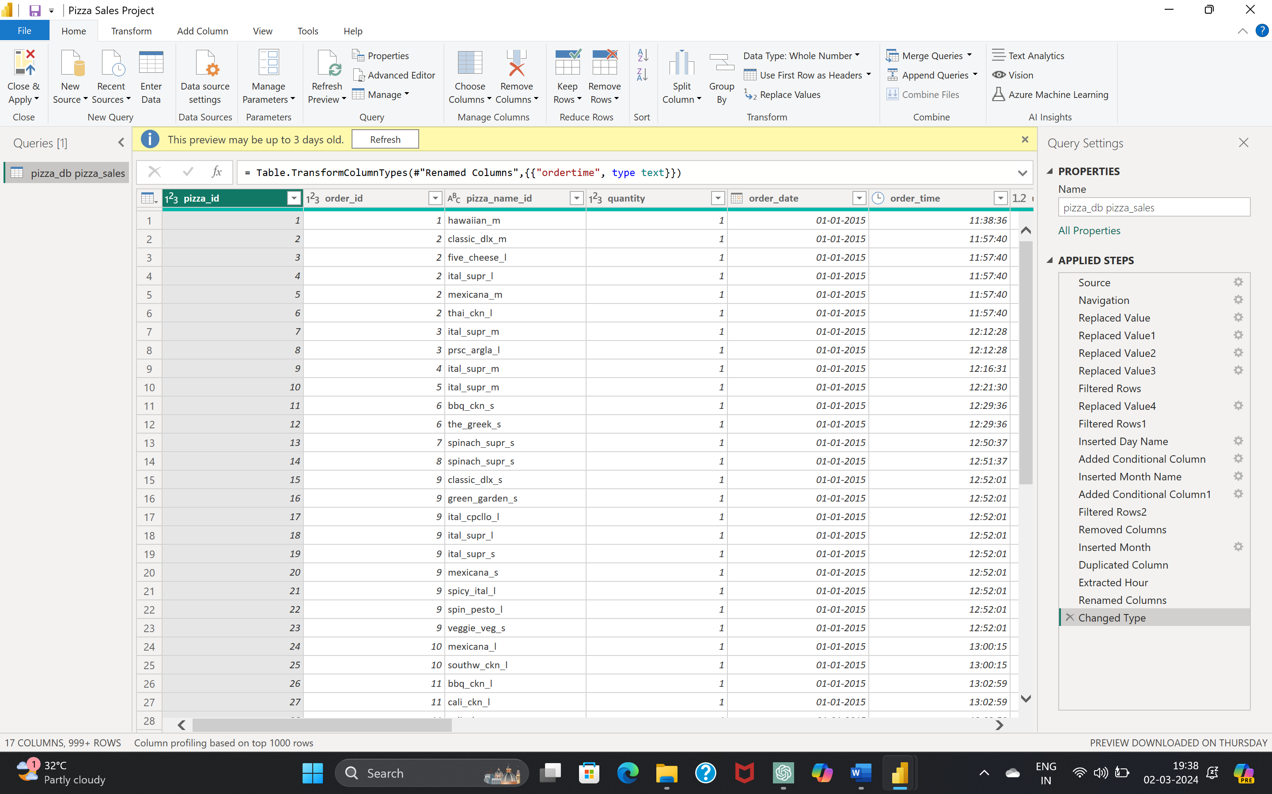

**8.Data Visualization**

* After Cleaning And Processing The Data According To The Requirements of Business Stakeholders, Prepare Dashboards’ For a Pizza Business To Gain Insights And Improve Decision-Making

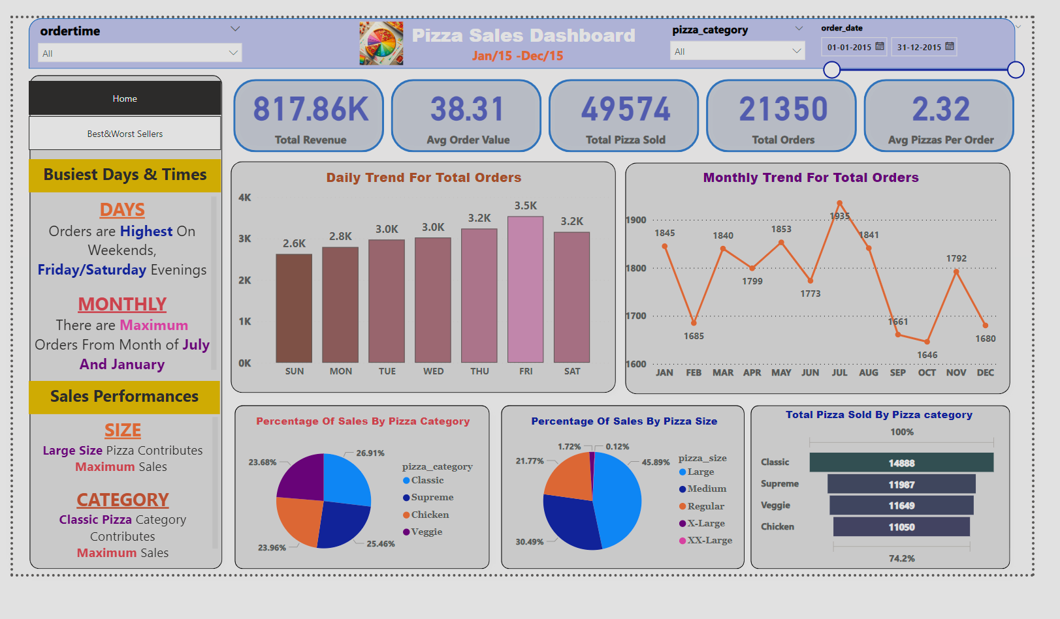

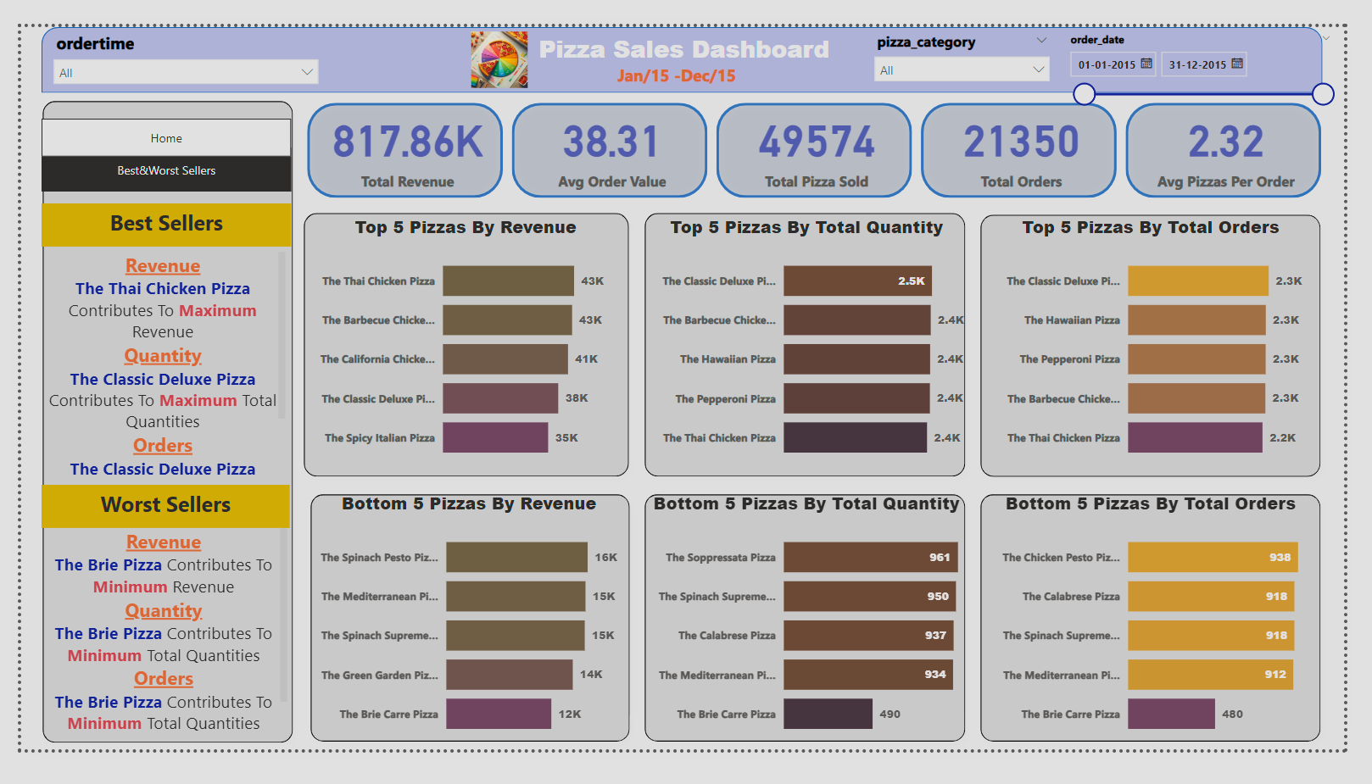

### **Conclusion:**

**Overall Performance:**

* + - The pizza sales data reveals a total revenue of **817.86K** with an average order value of **38.31**. This indicates a healthy financial performance.
    - A total of **49,574 pizzas** were sold, resulting in **21,350 orders**. On average, each order contains **2.32 pizzas**.
    - The Thai Chicken Pizza is the highest revenue-generating item, contributing significantly to the total revenue of **817.86K**.
    - The Classic Deluxe Pizza is popular in terms of quantity sold and total orders placed
* On average, each order contains approximately **2.32 pizzas**.

**Busiest Days and Times:**

* **Weekends**, particularly **Friday and Saturday evenings**, witness the highest order volumes. It’s crucial to allocate resources effectively during these peak hours.
* The months of **July and January** consistently show the maximum number of orders. Seasonal trends should be considered for inventory planning.

**Sales Performances:**

* **Large size pizzas** contribute significantly to overall sales. Focusing on promoting this category could yield further growth.
* The **classic pizza** category also plays a substantial role in sales.